**AML Assignment-4**

* Subhani Shaik(MT18117)

Q1.

Dataset: CIFAR 10

* Training data points:50k  and Testing data points:10k samples.
* CIFAR 10 has 10 classes like planes, automobiles etc. which can be identified independently than other classes.

**Implementation:**

* Our input image is of 3 channels and used padding=1.
* This architecture has Encoder and Decoder blocks and created those architecture as given.
* I have used the Adagrad and learning rate of 0.01.
* I have taken batch size of 64 and implemented Multi-Loss like classification loss at encoder and Reconstruction at decoder.
* Trained the model for 100 epochs and analysed the results by observing Train and Test losses, and Test accuracies.

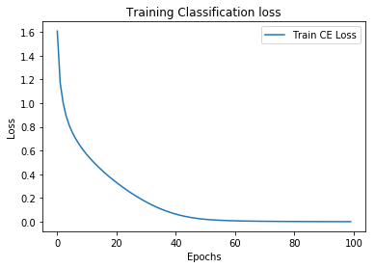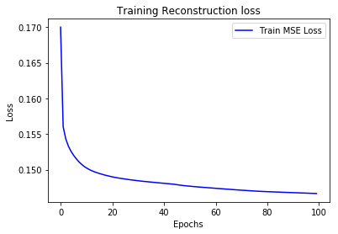

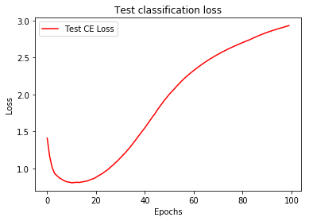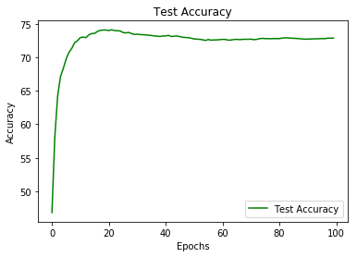

**AutoEncoder with classifier:**

* Implemented the auto encoder with classifier for classification of objects and reported the results.

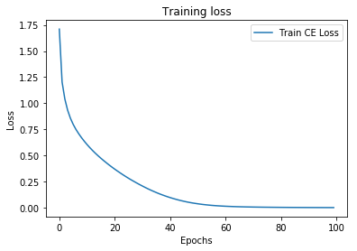

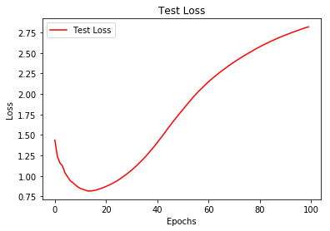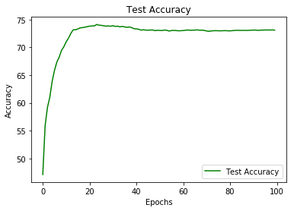

* In this architecture, after some epochs the training loss is converging and test loss was increasing i.e., model is overfitting.
* Please see the plots and PyNotebook for results.

**2.**

Dataset: CIFAR 10

Procedure:

* Implemented the given architecture and analysed the results.
* In this, implemented the ReLu and Tanh as activation functions.
* The model is overfitting, so added the dropout layers of rate 0.2,0.4,0.6 and analysed the results by taking train and test losses and test accuracies.
* Analysed the values of gradients and plotted the results.

Note: Please see PyNotebook and plots for results.

3.

Dataset: STL10

Procedure:

* Implemented the 5 layer Convolutional layers and analysed the results and plotted the values.
* Please the pynotebook.

4. Created the architecture.